**Sample Problem #1**

A high school student shoots a 0.040 kg arrow straight up in the air at 30.0 m/s during archery class in the school gym.

1. Assuming no air resistance, what is the maximum height that the arrow could reach?
2. What is the kinetic energy of the arrow when it strikes the ceiling at a height of 15.0 m?
3. How fast is the arrow going when it strikes the ceiling?

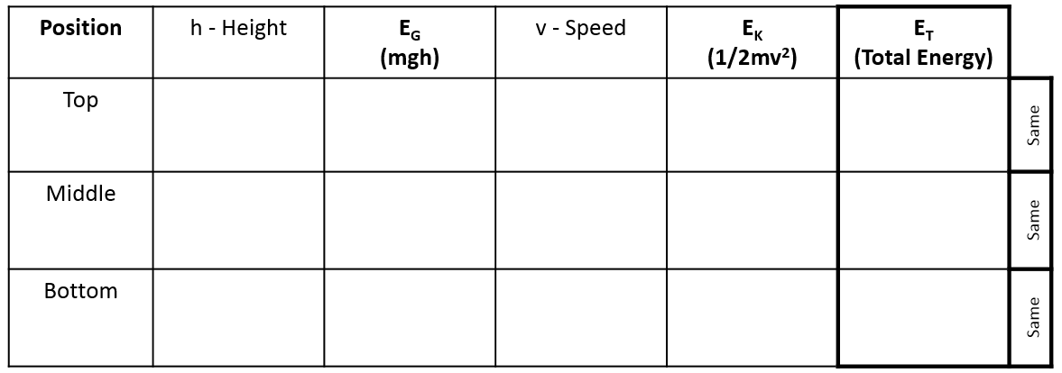

Solution Steps:

Fill in the solution table (above) using the following steps.

1. Identify the three (3) positions mentioned in the problem.
   * Top: height = ? (Maximum height of the arrow)
   * Middle: height = 15.0 m (Height of the ceiling)
   * Bottom: height = 0.00 m (Where student shoots the arrow from)
2. Fill in other speed (v) and height (h) information provided in the question text.
3. Calculate Eg at the bottom position:
4. Calcualte EK at the bottom position:
5. Add Eg and EK to get the Total Energy (ET) at the bottom position.
6. Since the Total Energy (ET) remains constant, it is the same at the bottom, middle and top positions.
7. Determine the speed (v) and EK at the top position
8. Subtract Ek from ET to find Eg at the top position
9. Solve for height (h) at the top position (Answer a)
10. Calculate Eg at the middle position
11. Subtract Eg from ET to find EK at the middle position (Answer b)
12. Solve for speed (v) at the middle position (Answer c)

**Sample Problem #2**

A 0.550 kg ball is thrown down from a cliff 30.0 m high with a speed of 5.00 m/s. Assume air resistance is negligible.

1. The ball’s initial kinetic, gravitational potential and total mechanical energy.
2. Find the ball’s potential energy at a height of 10.0 m above the ground and it’s kinetic energy at that height.
3. Find the ball’s speed just before it hits the ground.



Solution Steps:

Fill in the solution table (above) using the following steps.

1. Identify the three (3) positions mentioned in the problem.
   * Top: height = _______
   * Middle: height = _______
   * Bottom: height = _______
2. Fill in other speed (v) and height (h) information provided in the question text.
3. Calculate Eg at the top of the cliff position:
4. Calcualte EK at the top of the cliff position:
5. Add Eg and EK to get the Total Energy (ET) at the top of the cliff position. (Answer a)
6. Since the Total Energy (ET) remains constant, it is the same at the bottom, middle and top positions.
7. Calculate Eg at the 10.0 m position
8. Subtract Eg from ET to find EK at the 10.0 m position (Answer b)
9. Calculate Eg at the ground (0.00 m) position
10. Subtract Eg from ET to find EK at the ground (0.00 m) position
11. Solve for speed (v) at the ground (0.00 m) position (Answer c)